Lab 06: Arrays

Objective(s) : Upon completion of this lab session, learners will be able to:
- Apply Arrays in C++
- Use of One Dimesion Array

Arrays
So far we have been using only the standar data types: interger, character, floating point number, and Boolean. These types are useful but they only hande limited amout of data. To handle more data in programming language there are derived datatypes. Such datatype is Array structure.
Lets consider that we have a problem that requires us to read, process and print 10 interger values. To solve this problem we need to create 10 variables, each with different name as shown in below figure.
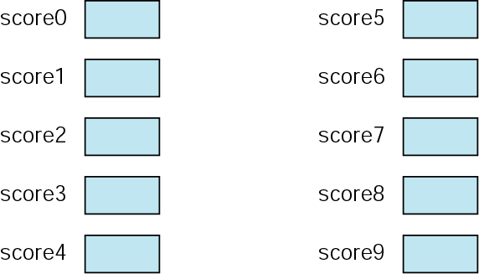

Having ten variables with different name is a problematic. How we can read 10 intergers from keyboard and store them? To read 10 variables from keyboard we need to write 10 read statements. Furthermore, once we have stored them in memory, we need to print them on screen, for that we need to write 10 print statement as well.
Althrough this approach is adaptable for 10 variables, what if we need to store, process and print 1000 interger variables? To process large amout of data, we need a powerfull structure that is Array. An Array is sequenced collection of elements of same data type. Following figure demonstrate the array of scores, that can store 10 interger values.

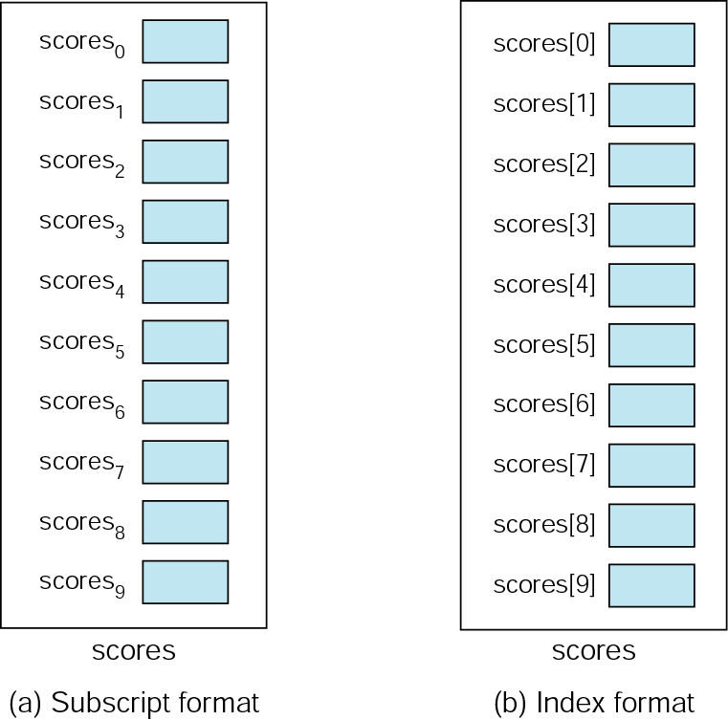

To store, process and print the values, we can use loops. Below figure demonstrates the flow of used to process 10 elements.
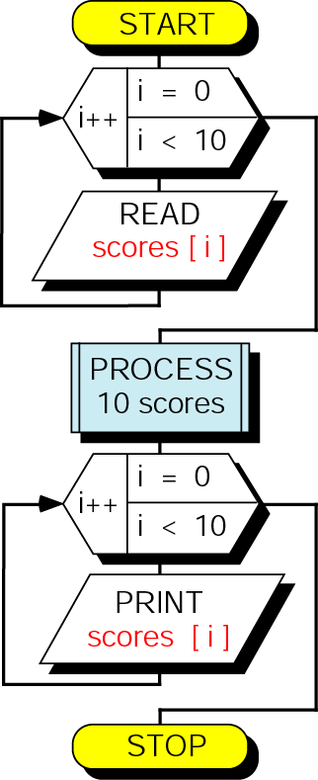
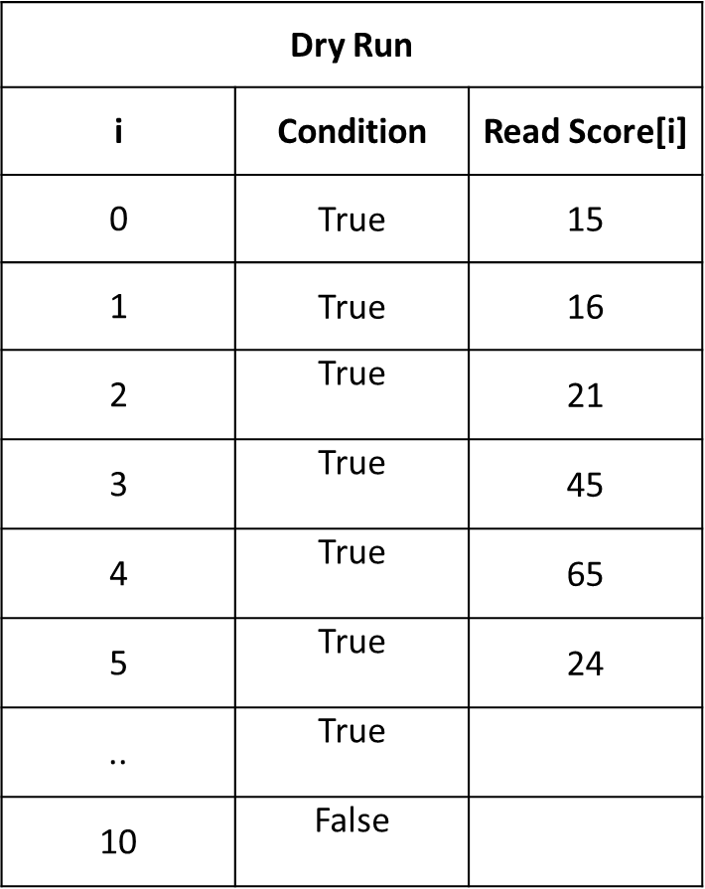

- One Dimension Array
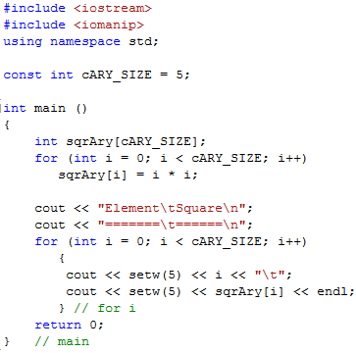
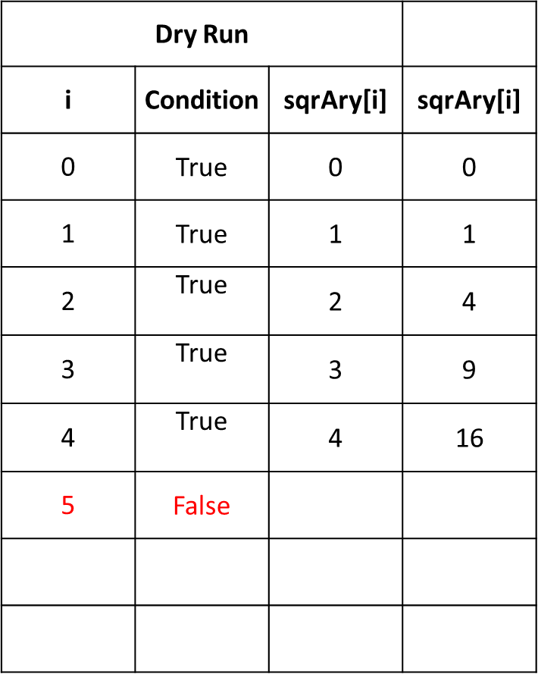
One dimension Array can have only single colum and N rows.

// Output
Elements Square
======== =======
0 0
1 1
2 4
3 9
4 16

EXERCISES
Exercise 1
Write a C++ program, that ask user to enter 10 integer values. Store those values in one dimension array. Create an other one dimension array of same size, and store the values of first array in reverse order. Print the results on screen.

Your Program should display output as follows:
#Sample Program Run#1
===================================
Matrix A – Original
===================================
12 23 25 4 6 8 2 7 9 11
===================================
Matrix A – Reverse
===================================
11 9 7 2 8 6 4 25 23 12

Exercise 2
Write a C++ Program that checks whether the two arrays are equal or not.
Declare two Interger Arrays with 7 elements, and fill up the array with keyboard input.
Test if every element in Array 1 is equal to corresponding element in Array 2. For example, the program should check A[0] = B[0], A[0] = B[0], and so for.
Your Program should display output as follows:
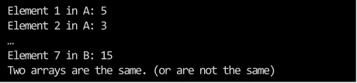

Sol
Exercise 3
Write a C++ Program, ask user to enter 10 interger values. Display its data graphically by plotting each numeric value as a bar of asterisks (*) as shown in the diagram
